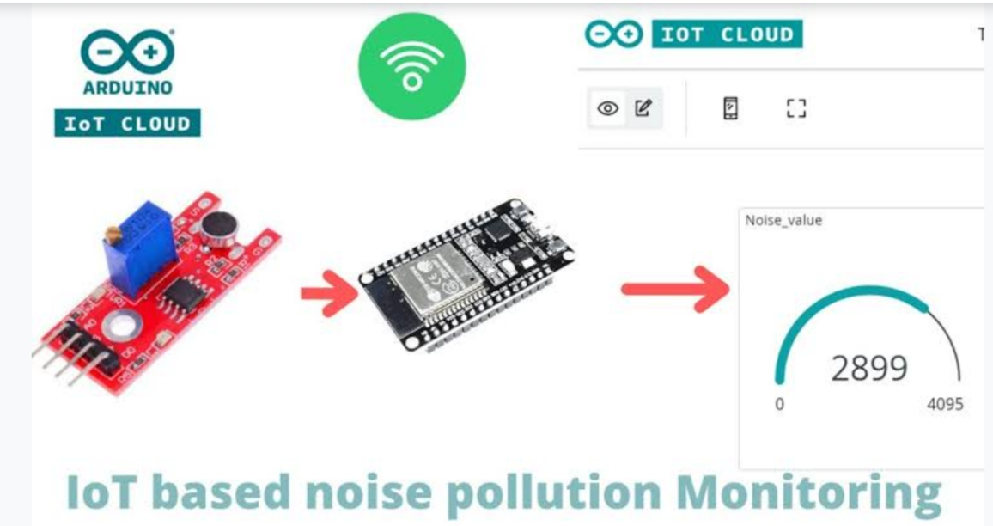

Abstract

Presently, noise pollution has become a very big issue around the world. The adverse effects of this pollution include hearing impairment, negative social behavior, annoyance, sleep disturbance and intelligibility to understand people’s speech. In learning context, noise can affect understanding and behavior of people and places with high noise level are not suitable for learning and teaching process.

Internet of Things (IoT) technology is one of the best choices to monitor the noise or sound intensity in the environment for the safety of human being. The aim of this paper is to deliver a development of an IoT based noise monitoring system comprises of a sound sensor, an IoT platform called NodeMCU, LCD and LEDs.

The system will provide a real-time alert if the noise exceeds the threshold noise limit set by Environmental Department of Health standard. Equipped with an Android application, the data from the sound sensor will be transferred into the cloud server and subsequently transferred into the app for display and to enable remote monitoring

Introduction

Internet of things or commonly called IoT refers to the network of physical devices, vehicles, Electronic appliances and other items embedded with sensors, software and connectivity which enables These things to connect, collect and exchange data without requiring human-to-human or human-to-Computer interaction . IoT is currently growing due to some factors such as convergence of multiple Technologies, real time analytics, machine learning, commodity sensor and embedded systems .

The Term IoT was firstly coined by Kavin Ashton of Procter and Gamble and later by MITs Auto-ID centre(1999). Cisco System estimated that IoT was developed between 2008 and 2009 . It is widely Used in today’s applications such as consumer, commercial, industrial and infrastructure spaces.

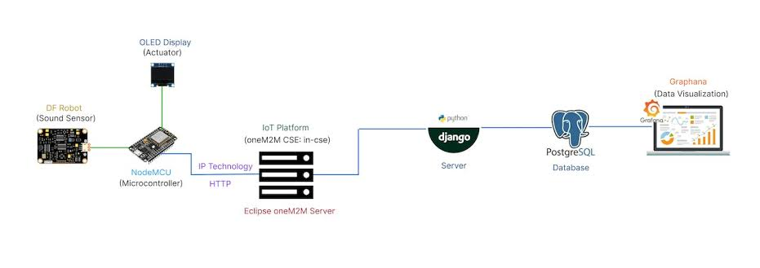 There Is a lot of thing that can be implemented for the consumers’ daily uses. Take a smart home for Instance, IoT is used in this invention to control lighting, heating, air-conditioning, media and security Systems.

The Noise Impact in the Learning-Teaching Process in an Elementary School

Unnecessary or emission of noise that is coming from surrounding of school environment can Become a barrier that distorts the communication within community inside the school. The aim of the project is to study the effect of noise from inside and outside of the school building also whether the noise can influence or not students’ performance in elementary school.

World Health Organization (WHO) suggests that the maximum noise level and reverberation for school is 35dB for classrooms and 55dB for outdoor activities and the recommended reverberation time is 0.6 sec .

The data for the project is collected by surveys and measurement of noise level using the sound level meter. Based on the results, there are various factors that contribute to noise level. However, the noise level around the school area still complies with normal level of noise but eventually it will affect the teaching-learning process of students.

Problem StatemenT

Noise monitoring is very crucial since 20% of the European Union (EU) population or close to 80 Million people suffer from noise level that experts consider to be unacceptable .IoT allows an Exchange of information to and from a device or thing and due to its flexibility and low cost, IoT Is getting popular day by day . Thus, IoT is very suitable to be implemented in monitoring the noise level in some areas to deal with the problem. The demands of modern society lead to the creation of noise sources such as industrial sources, transport vehicles, defence equipment and construction. The most significant example is inside UTM.

App Development

As the app was created by using Android Studio, the app will display the data taken from the sound sensor. Android Studio is a software to create app use JAVA language to design an Android Development. The app has four features which are the reading of sound level in dBA, the level of warning based on the reading of sound intensity, the possible sound that contributes to the sound level and the suitability for students to study. The app gives different level of warning such as “low”, “normal”, “high” and “very high”.

Results and Observations

The prototype is calibrated using actual sound level meter to get the accurate measurement of sound Level or sound intensity. The prototype is used to measure the sound level at five different times which are during morning, afternoon, evening, night and midnight at a place where UTM students are Staying. The reading is taken 30 minutes per range of time. Within that time, the lowest and highest sound intensity were recorded and from the readings, the range of sound level was determined during That specific range of time. The results are tabulated in Table 1

